Data Flow Diagram & User Stories
AI FAQ Assistant — Backend-Only RESTful API (Node.js / Express / MongoDB / JWT / Gemini AI)
Date | 26 September 2026
Team ID | 6ab4aef20fc666a751b4634f
Project Name | AI FAQ Assistant
Maximum Marks | 4 Marks
Project Type: Backend-only RESTful API (no frontend/UI layer) — built with Node.js, Express.js, MongoDB (Mongoose), JWT authentication and the Google Gemini API; tested and consumed through Postman / client applications.
Part 1: Data Flow Diagram (Text Description)
Level-0 (Context) DFD
The Level-0 context diagram treats the entire AI FAQ Assistant API as a single process — “0. AI FAQ Assistant API (System)” — with three external entities interacting across the system boundary. No data stores are shown at this level (MongoDB is internal to the system).
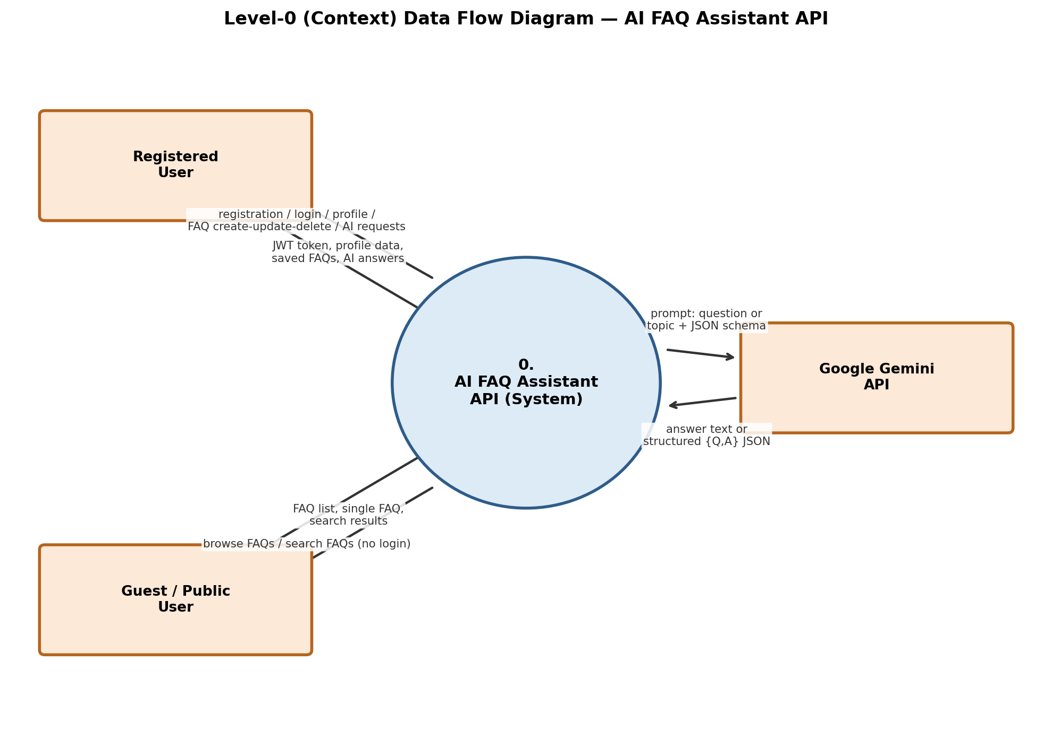
Figure 1: Level-0 Context Data Flow Diagram
External Entities: (a) Registered User (b) Guest / Public User (c) Google Gemini API
Level-0 data flows:
1. Registered User → System: registration details (name, email, password)
2. System → Registered User: success message + JWT token
3. Registered User → System: login credentials (email, password)
4. System → Registered User: JWT token
5. Registered User → System: profile request (Bearer token)
6. System → Registered User: profile details (password excluded)
7. Registered User → System: FAQ create / update / delete request (Bearer token + FAQ data)
8. System → Registered User: saved / updated FAQ or delete confirmation (or 403/404 error)
9. Registered User → System: AI request — free-text question or topic (Bearer token)
10. System → Registered User: direct AI answer or generated {question, answer} pair
11. Guest User → System: browse request — get all FAQs / get FAQ by ID (no token required)
12. System → Guest User: FAQ list (newest first, with creator details) or single FAQ
13. Guest User → System: search query (?q=keyword)
14. System → Guest User: list of matching FAQs
15. System → Google Gemini API: prompt — free-text question, or topic with a structured JSON schema
16. Google Gemini API → System: answer text, or structured {question, answer} JSON
Level-1 DFD
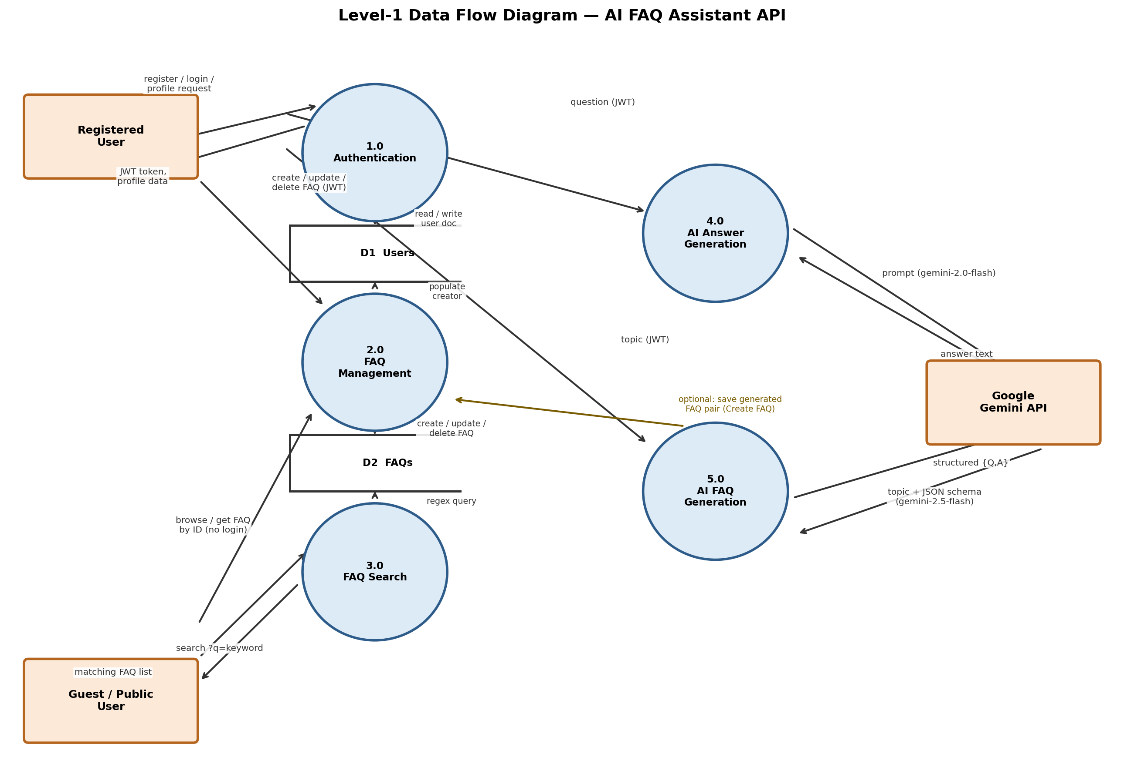
The Level-1 diagram decomposes the system into five processes and two data stores, interacting with the same three external entities.
Processes:
• 1.0 Authentication — registration, login, profile retrieval, and JWT verification middleware
• 2.0 FAQ Management — create / update / delete with ownership checks, list all FAQs, get FAQ by ID
• 3.0 FAQ Search — case-insensitive keyword search
• 4.0 AI Answer Generation — direct answers via gemini-2.0-flash
• 5.0 AI FAQ Generation — topic → FAQ pair via gemini-2.5-flash (structured JSON schema)
Data Stores:
• D1 — Users collection (MongoDB: name, email, bcrypt-hashed password)
• D2 — FAQs collection (MongoDB: question, answer, category, createdBy, timestamps)
Level-1 data flows (grouped by process):
Process 1.0 — Authentication
1. Registered User → 1.0: registration details (name, email, password)
2. 1.0 → D1 (Users): duplicate-email check (read)
3. 1.0 → D1 (Users): new user document with bcrypt-hashed password (write)
4. 1.0 → Registered User: success message + JWT token
5. Registered User → 1.0: login credentials (email, password)
6. 1.0 → D1 (Users): fetch user record by email (read)
7. 1.0 → Registered User: JWT token (after bcrypt hash comparison)
8. Registered User → 1.0: profile request with “Bearer <token>”
9. 1.0 → D1 (Users): read user document
10. 1.0 → Registered User: profile details (password excluded)
11. Registered User → 1.0: “Bearer <token>” on every protected request — 1.0 verifies the token (missing / invalid / expired tokens are rejected) and forwards the authenticated request to 2.0, 4.0 or 5.0
Process 2.0 — FAQ Management
12. Registered User → 2.0: create FAQ (question, answer, category) — via 1.0 (JWT verified) and validation middleware
13. 2.0 → D2 (FAQs): write new FAQ document {question, answer, category, createdBy = user ID, timestamps}
14. 2.0 → Registered User: created-FAQ confirmation
15. Registered User → 2.0: update / delete request for a specific FAQ ID
16. 2.0 → D2 (FAQs): read the FAQ and compare createdBy with the requesting user's ID (ownership check)
17. 2.0 → D2 (FAQs): write the updated FAQ, or delete the document
18. 2.0 → Registered User: updated FAQ / delete success (403 Forbidden if not the creator)
19. Guest User → 2.0: GET /api/faqs (all) or GET /api/faqs/:id — public, no token required
20. 2.0 → D2 (FAQs) and D1 (Users): read FAQs sorted newest first; read creator name/email (populate)
21. 2.0 → Guest User: FAQ list with creator details, or single FAQ (404 if not found; cast error for an invalid ObjectId)
Process 3.0 — FAQ Search
22. Guest User → 3.0: search request ?q=keyword — public, no token required
23. 3.0 → D2 (FAQs): case-insensitive regex query across question, answer and category
24. 3.0 → Guest User: list of matching FAQs
Process 4.0 — AI Answer Generation
25. Registered User → 4.0: free-text question — via 1.0 (JWT verified) and validation middleware
26. 4.0 → Google Gemini API: question prompt (gemini-2.0-flash)
27. Google Gemini API → 4.0: direct answer text
28. 4.0 → Registered User: concise answer (JSON response)
Process 5.0 — AI FAQ Generation
29. Registered User → 5.0: topic string — via 1.0 (JWT verified) and validation middleware
30. 5.0 → Google Gemini API: topic with a structured JSON schema (gemini-2.5-flash)
31. Google Gemini API → 5.0: structured {question, answer} JSON pair
32. 5.0 → Registered User: generated FAQ pair
33. Registered User → 2.0 (optional): Create FAQ request with the generated pair — 2.0 writes it to D2 (FAQs) for permanent storage
Cross-cutting notes (for drawing the diagram):
• Input-validation middleware screens every write / AI request body (required fields, email format, password length ≥ 6, valid category, non-empty AI input) before the process logic executes; a failed validation goes straight to the error handler.
• Every process routes its failures (validation errors, invalid ObjectId / CastError, duplicate keys, 401/403 unauthorized, DB errors) through the centralized error-handling middleware, which returns a consistent JSON error response to the originating actor. This can be drawn as an annotation or an auxiliary process feeding back to both external entities.

Part 2: User Stories
User Type | Functional Requirement (Epic) | User Story Number | User Story / Task | Acceptance criteria | Priority | Release
Guest User (new visitor) | Registration | USN-1 | As a guest user, I can register for an account by providing my name, email and password, so that I can gain access to FAQ management and AI features. | POST /api/auth/register creates the account with name, email and password; a duplicate email is rejected; the password is stored hashed (bcrypt, 10 salt rounds); a JWT token is returned on success. | High | Sprint-1
Registered User | Login | USN-2 | As a registered user, I can log in with my email and password, so that I receive a JWT token for accessing protected endpoints. | POST /api/auth/login with valid credentials returns a JWT token; incorrect credentials return an error and no token. | High | Sprint-1
Registered User | Profile Management | USN-3 | As a registered user, I can view my profile by sending my JWT token, so that I can see my stored account details. | GET /api/auth/profile with a valid “Bearer <token>” returns my details with the password excluded; requests with missing, invalid or expired tokens are rejected. | Medium | Sprint-1
Registered User | FAQ Creation | USN-4 | As a registered user, I can create a new FAQ by providing a question, answer and valid category, so that it is stored and becomes available to everyone. | POST /api/faqs (protected) saves the FAQ with my user ID as createdBy plus timestamps; a missing/invalid category (must be Technology, Education, Health, Banking or General) is rejected by validation middleware; the FAQ appears in the FAQ list immediately. | High | Sprint-1
Registered User | FAQ Update & Deletion | USN-5 | As a registered user, I can update an FAQ I created (question, answer and/or category), so that I can keep my content accurate. | PUT /api/faqs/:id (protected) updates my own FAQ and returns the updated document; targeting another user's FAQ returns 403; a malformed ObjectId returns a cast-error response. | Medium | Sprint-1
Registered User | FAQ Update & Deletion | USN-6 | As a registered user, I can delete an FAQ I created, so that outdated content is removed from the system. | DELETE /api/faqs/:id (protected) removes my own FAQ and returns a success message; attempting to delete another user's FAQ returns 403; a non-existent ID returns 404. | Medium | Sprint-1
Guest User | FAQ Listing & Retrieval | USN-7 | As a guest user, I can browse all FAQs without logging in, so that I can read the knowledge base. | GET /api/faqs (public) returns all FAQs sorted newest first, with each FAQ's creator name and email populated; no authentication required. | High | Sprint-1
Guest User | FAQ Listing & Retrieval | USN-8 | As a guest user, I can retrieve a single FAQ by its ID, so that I can view a specific entry. | GET /api/faqs/:id (public) returns the FAQ when the ID is a valid ObjectId that exists; malformed IDs and missing FAQs return a consistent error (cast error / 404). | Medium | Sprint-1
Guest User | FAQ Search | USN-9 | As a guest user, I can search FAQs by keyword, so that I can quickly find relevant entries. | GET /api/faqs/search?q=keyword (public) returns every FAQ whose question, answer or category matches the keyword case-insensitively (regex); no login required. | Medium | Sprint-2
Registered User | AI Answer Generation | USN-10 | As a registered user, I can submit any free-text question to the AI, so that I receive a direct, concise answer. | POST /api/ai/answer (protected) accepts a non-empty question, calls Gemini (gemini-2.0-flash) and returns the answer; empty input is rejected by validation middleware before any API call is made. | High | Sprint-2
Registered User | AI FAQ Generation | USN-11 | As a registered user, I can provide a topic and have the AI generate an FAQ pair, so that I can author content faster. | POST /api/ai/generate-faq (protected) accepts a non-empty topic, calls Gemini (gemini-2.5-flash) with a structured JSON schema, and returns a valid {question, answer} pair. | Medium | Sprint-2
Registered User | AI FAQ Generation | USN-12 | As a registered user, I can save an AI-generated FAQ pair via the Create FAQ endpoint, so that it is stored permanently in the FAQ collection. | The {question, answer} pair returned by /api/ai/generate-faq can be submitted to POST /api/faqs with a valid category; the saved FAQ stores my user ID as creator and immediately appears in the public FAQ list. | Medium | Sprint-2

